CS4093 - Assignment 2
Alexander Stradnic - 119377263
Majority Gate: A Majority Gate takes in a set of inputs and returns the output of the majority of the input signals. For example, with 3 inputs, if 2 or more inputs are enabled, then the output is 1, vice versa when 2 or more are disabled.

A | B | C | Y
0 | 0 | 0 | 0
0 | 0 | 1 | 0
0 | 1 | 0 | 0
0 | 1 | 1 | 1
1 | 0 | 0 | 0
1 | 0 | 1 | 1
1 | 1 | 0 | 1
1 | 1 | 1 | 1

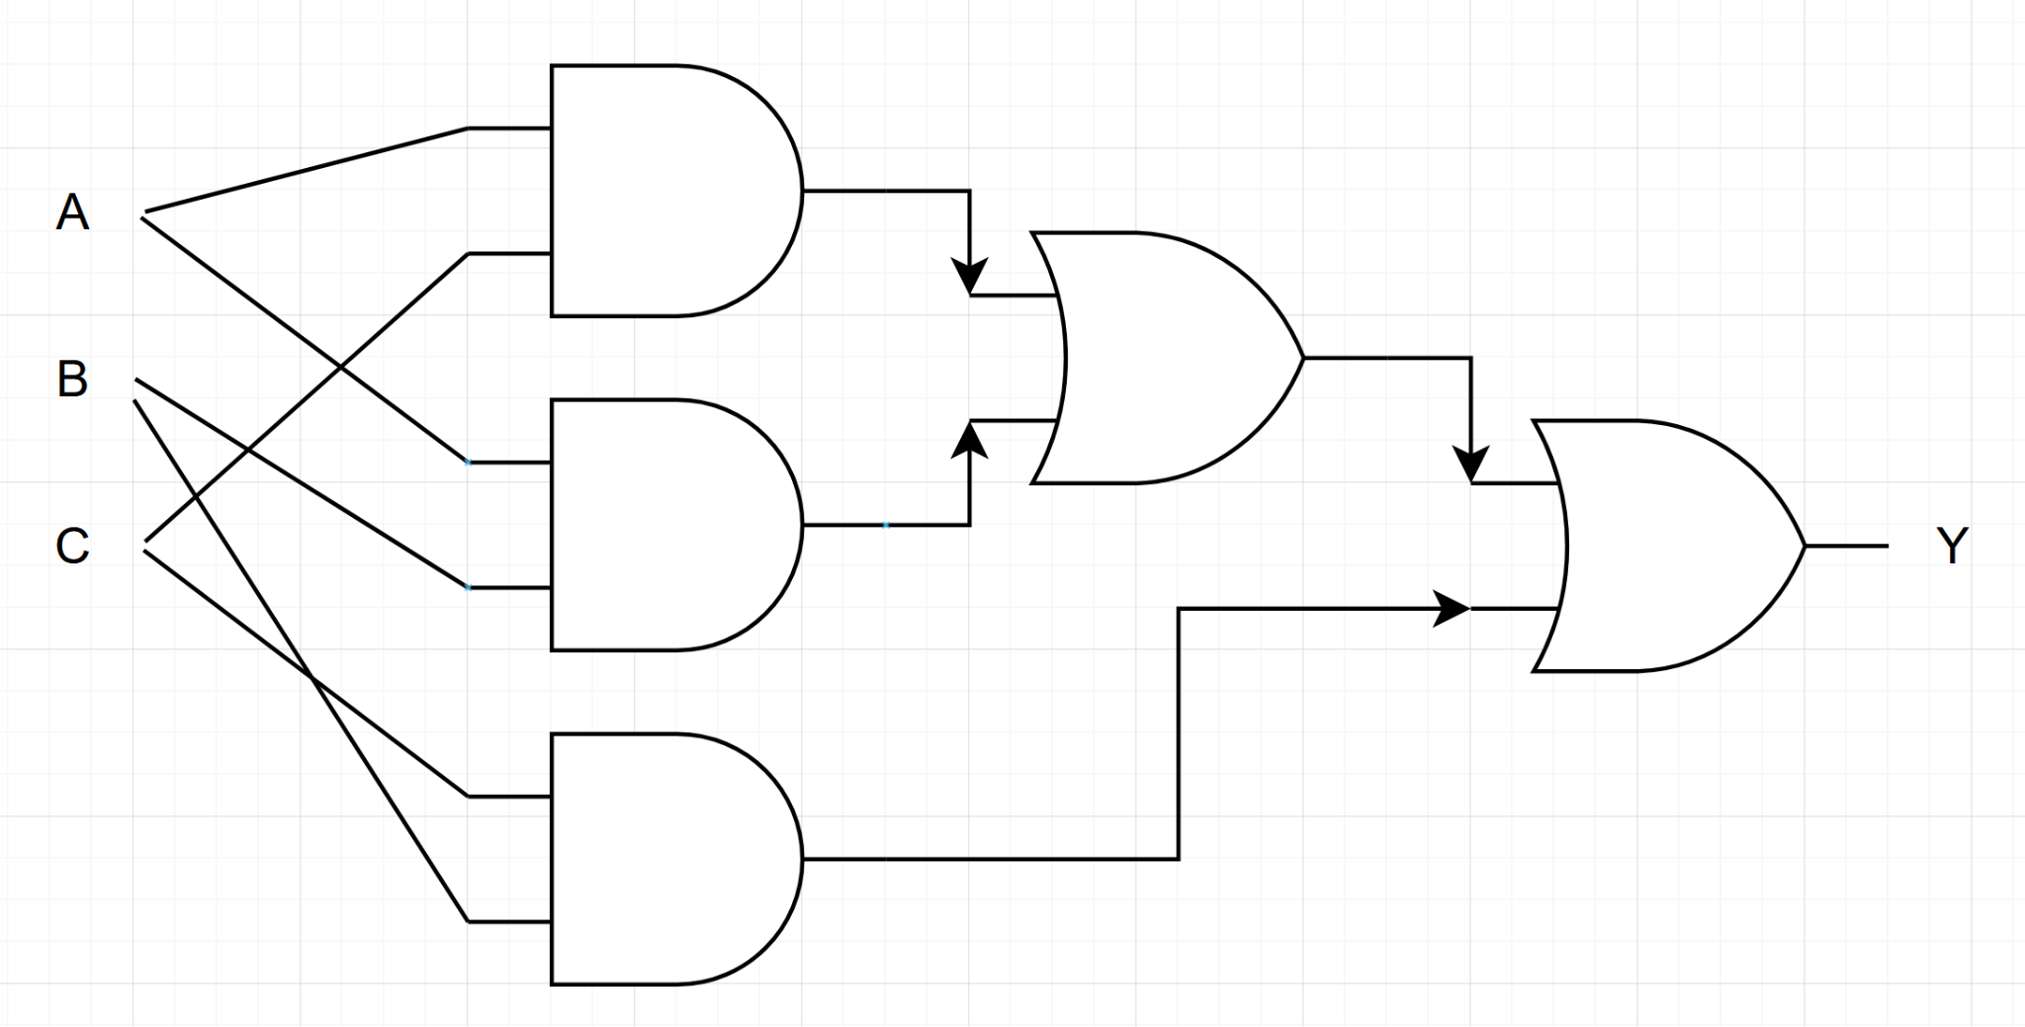

Verilog Code
module majority_gate (y,a,b,c);
input a,b,c;
output y;
assign y = (a&&b)||(b&&c)||(a&&c);
endmodule

Testbench Code
module TEST;
reg a, b, c;
wire y;
majority_gate TEST (.y(y), .a(a), .b(b), .c(c));
initial begin
$dumpfile("dump.vcd");
$dumpvars(1);
a=0;
b=0;
c=0;
#10;
a=0;
b=0;
c=0;
#10;
a=0;
b=1;
c=0;
#10;
a=0;
b=1;
c=1;
#10;
a=1;
b=0;
c=0;
#10;
a=1;
b=0;
c=1;
#10;
a=1;
b=1;
c=0;
#10;
a=1;
b=1;
c=1;
#10;
end
endmodule

Waveform

Full Adder: A Full Adder works in a similar manner to a half-adder, which takes two bits and outputs the sum and a carry if needed. However, an extra input is handled which is usually taken to be the carry bit from a previous adder.

A | B | Cin | Sum | Cout
0 | 0 | 0 | 0 | 0
0 | 0 | 1 | 1 | 0
0 | 1 | 0 | 1 | 0
0 | 1 | 1 | 0 | 1
1 | 0 | 0 | 1 | 0
1 | 0 | 1 | 0 | 1
1 | 1 | 0 | 0 | 1
1 | 1 | 1 | 1 | 1
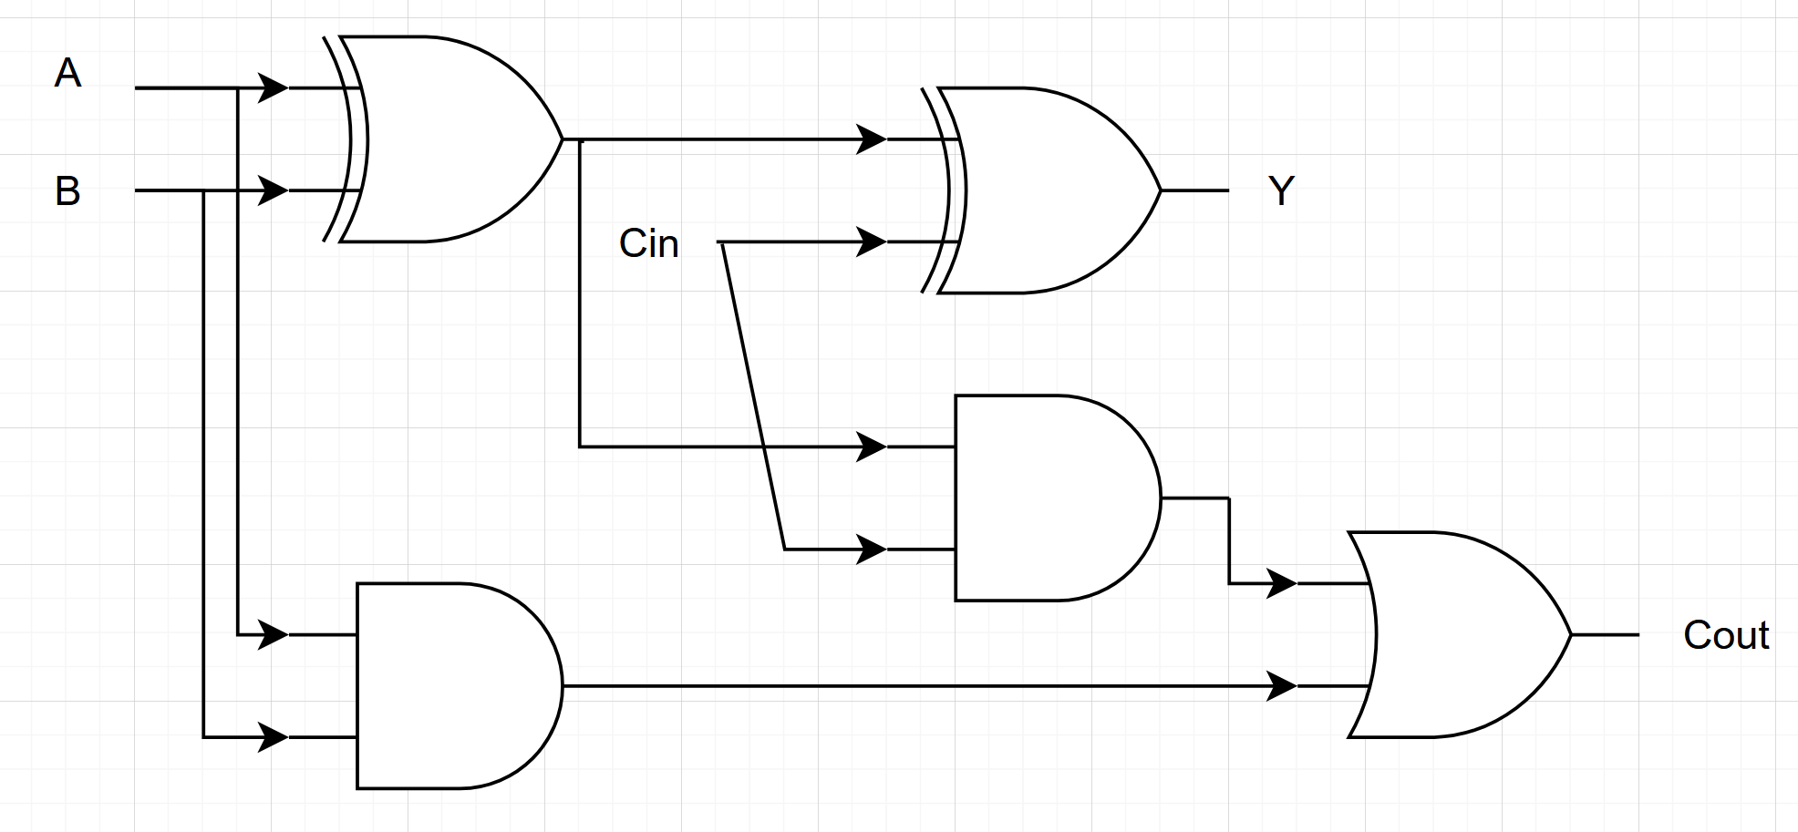

Verilog Code
module full_adder (y,cout,a,b,c);
input a,b,c;
output y, cout;
reg y, cout;
always @(*) begin
if(a + b + c == 0) begin
y <= 0;
cout <= 0;
end else if(a + b + c == 1) begin
y <= 1;
cout <= 0;
end else if(a + b + c == 2) begin
y <= 0;
cout <= 1;
end else if(a + b + c == 3) begin
y <= 1;
cout <= 1;
end
end
endmodule

Testbench Code:
module TEST;
reg a, b, c;
wire y, cout;
full_adder TEST (.y(y), .cout(cout), .a(a), .b(b), .c(c));
initial begin
$dumpfile("dump.vcd");
$dumpvars(1);
a=0;
b=0;
c=0;
#10;
a=0;
b=0;
c=0;
#10;
a=0;
b=1;
c=0;
#10;
a=0;
b=1;
c=1;
#10;
a=1;
b=0;
c=0;
#10;
a=1;
b=0;
c=1;
#10;
a=1;
b=1;
c=0;
#10;
a=1;
b=1;
c=1;
#10;
end
endmodule

Waveform

4:16 Encoder: A 4:16 Encoder works by converting an a series of 16 inputs to a 4-bit encoded number

I15 | I14 | I13 | I12 | I11 | I10 | I9 | I8 | I7 | I6 | I5 | I4 | I3 | I2 | I1 | I0 | O3 | O2 | O1 | O0
0 | 0 | 0 | 0 | 0 | 0 | 0 | 0 | 0 | 0 | 0 | 0 | 0 | 0 | 0 | 1 | 0 | 0 | 0 | 0
0 | 0 | 0 | 0 | 0 | 0 | 0 | 0 | 0 | 0 | 0 | 0 | 0 | 0 | 1 | 0 | 0 | 0 | 0 | 1
0 | 0 | 0 | 0 | 0 | 0 | 0 | 0 | 0 | 0 | 0 | 0 | 0 | 1 | 0 | 0 | 0 | 0 | 1 | 0
0 | 0 | 0 | 0 | 0 | 0 | 0 | 0 | 0 | 0 | 0 | 0 | 1 | 0 | 0 | 0 | 0 | 0 | 1 | 1
0 | 0 | 0 | 0 | 0 | 0 | 0 | 0 | 0 | 0 | 0 | 1 | 0 | 0 | 0 | 0 | 0 | 1 | 0 | 0
0 | 0 | 0 | 0 | 0 | 0 | 0 | 0 | 0 | 0 | 1 | 0 | 0 | 0 | 0 | 0 | 0 | 1 | 0 | 1
0 | 0 | 0 | 0 | 0 | 0 | 0 | 0 | 0 | 1 | 0 | 0 | 0 | 0 | 0 | 0 | 0 | 1 | 1 | 0
0 | 0 | 0 | 0 | 0 | 0 | 0 | 0 | 1 | 0 | 0 | 0 | 0 | 0 | 0 | 0 | 0 | 1 | 1 | 1
0 | 0 | 0 | 0 | 0 | 0 | 0 | 1 | 0 | 0 | 0 | 0 | 0 | 0 | 0 | 0 | 1 | 0 | 0 | 0
0 | 0 | 0 | 0 | 0 | 0 | 1 | 0 | 0 | 0 | 0 | 0 | 0 | 0 | 0 | 0 | 1 | 0 | 0 | 1
0 | 0 | 0 | 0 | 0 | 1 | 0 | 0 | 0 | 0 | 0 | 0 | 0 | 0 | 0 | 0 | 1 | 0 | 1 | 0
0 | 0 | 0 | 0 | 1 | 0 | 0 | 0 | 0 | 0 | 0 | 0 | 0 | 0 | 0 | 0 | 1 | 0 | 1 | 1
0 | 0 | 0 | 1 | 0 | 0 | 0 | 0 | 0 | 0 | 0 | 0 | 0 | 0 | 0 | 0 | 1 | 1 | 0 | 0
0 | 0 | 1 | 0 | 0 | 0 | 0 | 0 | 0 | 0 | 0 | 0 | 0 | 0 | 0 | 0 | 1 | 1 | 0 | 1
0 | 1 | 0 | 0 | 0 | 0 | 0 | 0 | 0 | 0 | 0 | 0 | 0 | 0 | 0 | 0 | 1 | 1 | 1 | 0
1 | 0 | 0 | 0 | 0 | 0 | 0 | 0 | 0 | 0 | 0 | 0 | 0 | 0 | 0 | 0 | 1 | 1 | 1 | 1
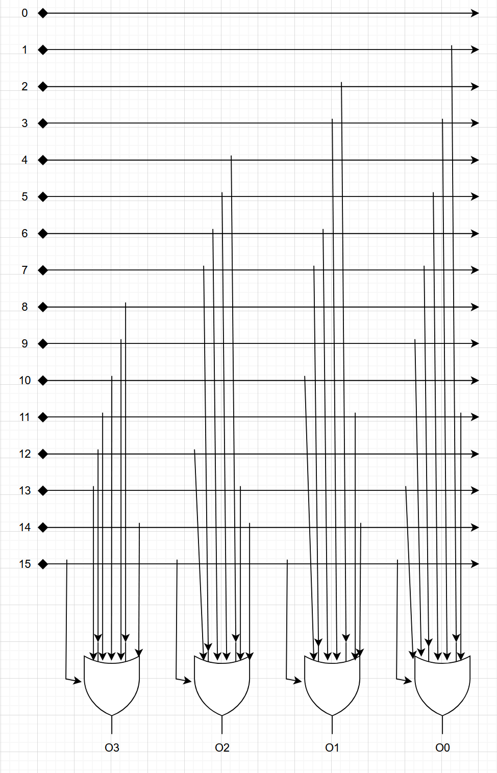
Verilog Code
module encoder (i0,i1,i2,i3,i4,i5,i6,i7,i8,i9,i10,i11,i12,i13,i14,i15,o3,o2,o1,o0);
input i0,i1,i2,i3,i4,i5,i6,i7,i8,i9,i10,i11,i12,i13,i14,i15;
output o3,o2,o1,o0;
reg o3,o2,o1,o0;
always @(*) begin
o0 <= 0;
o1 <= 0;
o2 <= 0;
o3 <= 0;
if(i1 | i3 | i5 | i7 | i9 | i11 | i13 | i15) begin
o0 <= 1;
end
if(i2 | i3 | i6 | i7 | i10 | i11 | i14 | i15) begin
o1 <= 1;
end
if(i4 | i5 | i6 | i7 | i12 | i13 | i14 | i15) begin
o2 <= 1;
end
if(i8 | i9 | i10 | i11 | i12 | i13 | i14 | i15) begin
o3 <= 1;
end
end
endmodule

Testbench Code
module TEST;
reg i0,i1,i2,i3,i4,i5,i6,i7,i8,i9,i10,i11,i12,i13,i14,i15;
wire o3,o2,o1,o0;
encoder TEST (.i0(i0), .i1(i1), .i2(i2), .i3(i3), .i4(i4), .i5(i5), .i6(i6), .i7(i7), .i8(i8), .i9(i9), .i10(i10), .i11(i11), .i12(i12), .i13(i13), .i14(i14), .i15(i15), .o3(o3), .o2(o2), .o1(o1), .o0(o0));
initial begin
$dumpfile("dump.vcd");
$dumpvars(1);
{i0, i1, i2, i3, i4, i5, i6, i7, i8, i9, i10, i11, i12, i13, i14, i15} = 16'b0;
#10;
i0 = 1;
#10;
i0 = 0;
i1 = 1;
#10;
i1 = 0;
i2 = 1;
#10;
i2 = 0;
i3 = 1;
#10;
i3 = 0;
i4 = 1;
#10;
i4 = 0;
i5 = 1;
#10;
i5 = 0;
i6 = 1;
#10;
i6 = 0;
i7 = 1;
#10;
i7 = 0;
i8 = 1;
#10;
i8 = 0;
i9 = 1;
#10;
i9 = 0;
i10 = 1;
#10;
i10 = 0;
i11 = 1;
#10;
i11 = 0;
i12 = 1;
#10;
i12 = 0;
i13 = 1;
#10;
i13 = 0;
i14 = 1;
#10;
i14 = 0;
i15 = 1;
#10;
end
endmodule

Waveform
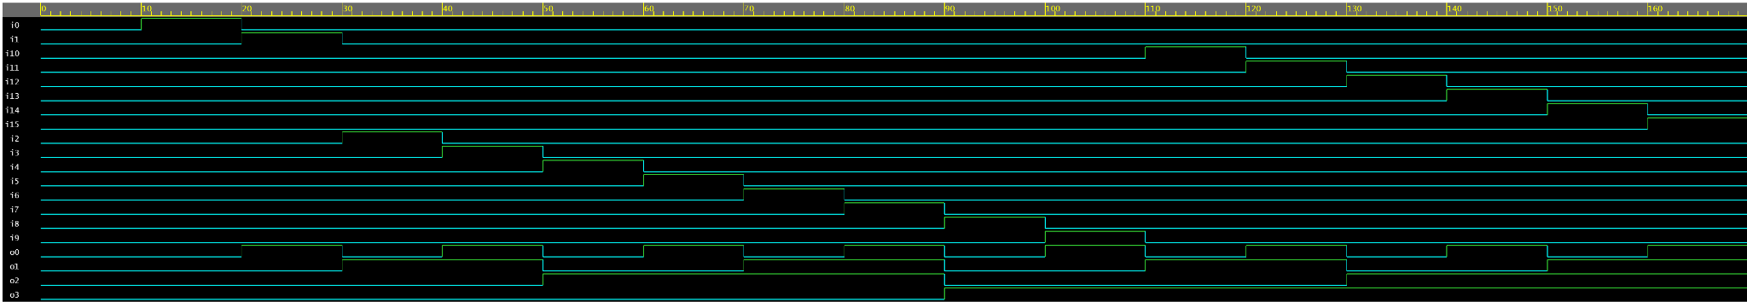

Multiplexer: A multiplexer acts like a switch between inputs, using selector switch line(s) to choose which input is outputted.

A | B | C | D | S1 | S0 | Y
 |  |  |  | 0 | 0 | A
 |  |  |  | 0 | 1 | B
 |  |  |  | 1 | 0 | C
 |  |  |  | 1 | 1 | D
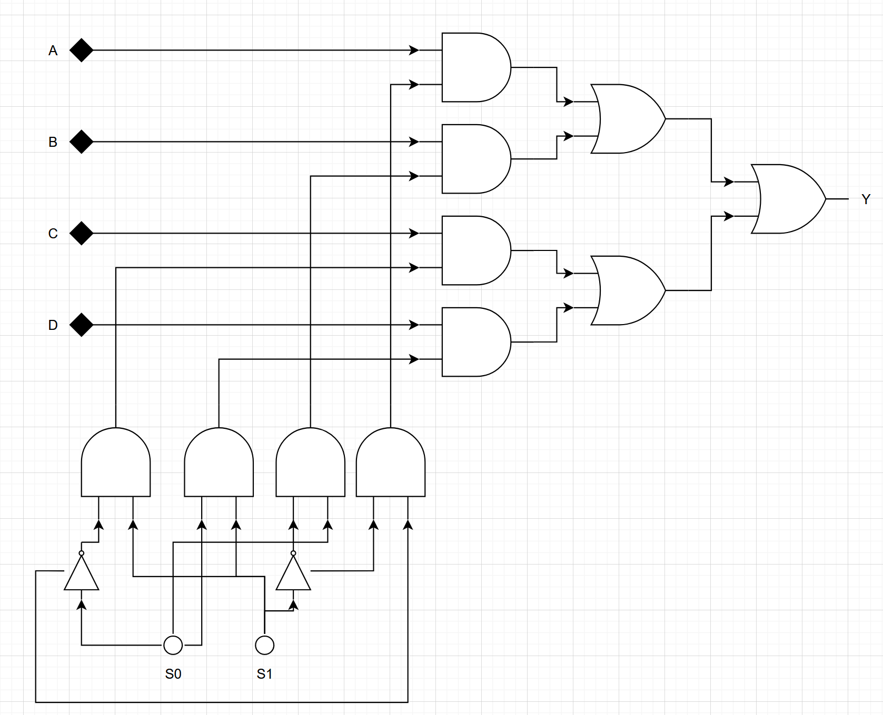
Verilog Code
module multiplexer (i0,i1,i2,i3,s0,s1,y);
input i0,i1,i2,i3,s0,s1;
output y;
reg y;
always @(*) begin
if(s0) begin
if(s1) begin
y <= i3;
end
else begin
y <= i1;
end
end else if(s1) begin
y <= i2;
end else begin
y <= i0;
end
end
endmodule

Testbench Code
module TEST;
reg i0,i1,i2,i3,s0,s1;
wire y;
multiplexer TEST (.i0(i0), .i1(i1), .i2(i2), .i3(i3), .s0(s0), .s1(s1), .y(y));
initial begin
$dumpfile("dump.vcd");
$dumpvars(1);
i0 = 1;
i1 = 1;
{s0, s1, i2, i3} = 4'b0;
// [s1][s0] = 00, inc from 00 to 11
#10;
s0 = 1;
#10;
s0 = 0;
s1 = 1;
#10;
s0 = 1;
#10;
end
endmodule

Waveform

Demultiplexer: A demultiplexer acts in the opposite manner to a multiplexer, with a single input being routed to a selected output line.

Y | S1 | S0 | O0 | O1 | O2 | O3
Y | 0 | 0 | Y | 0 | 0 | 0
Y | 0 | 1 | 0 | Y | 0 | 0
Y | 1 | 0 | 0 | 0 | Y | 0
Y | 1 | 1 | 0 | 0 | 0 | Y

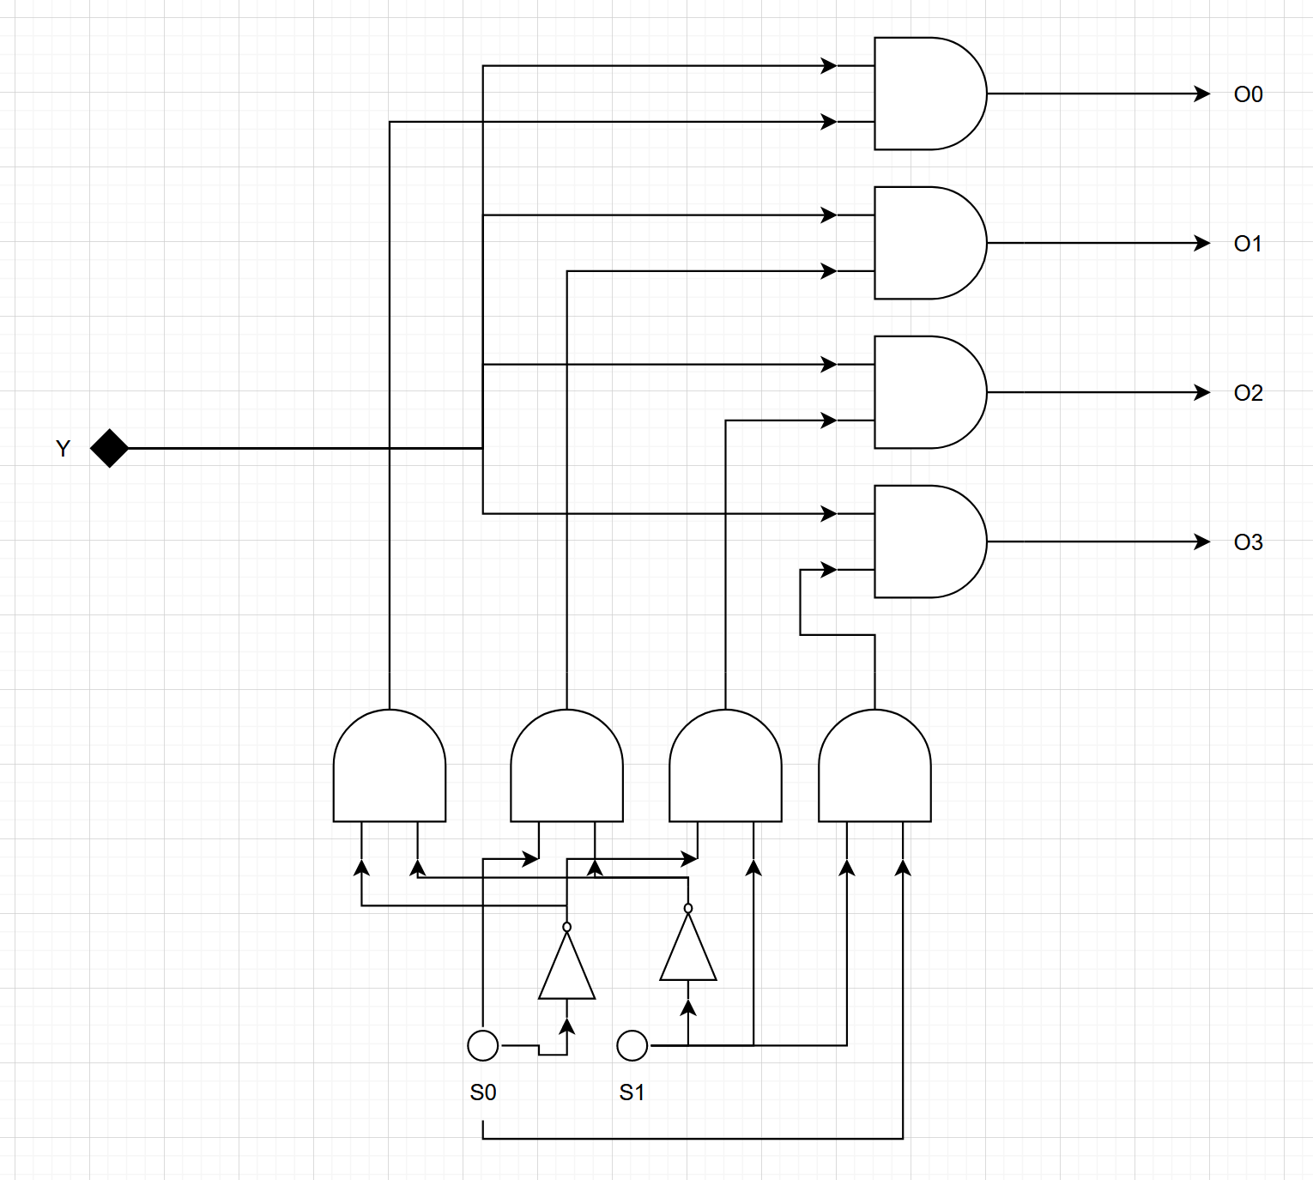
Verilog Code
module demultiplexer (o0,o1,o2,o3,s0,s1,y);
input y,s0,s1;
output o0,o1,o2,o3;
reg o0,o1,o2,o3;
always @(*) begin
{o0, o1, o2, o3} = 4'b0;
if(s0) begin
if(s1) begin
o3 <= y;
end
else begin
o1 <= y;
end
end else if(s1) begin
o2 <= y;
end else begin
o0 <= y;
end
end
endmodule

Testbench Code
module TEST;
reg y, s0, s1;
wire o0, o1, o2, o3;
demultiplexer TEST (.o0(o0), .o1(o1), .o2(o2), .o3(o3), .s0(s0), .s1(s1), .y(y));
initial begin
$dumpfile("dump.vcd");
$dumpvars(1);
y = 1;
s0 = 0;
s1 = 0;
// [s1][s0] = 00, inc from 00 to 11
#10;
s0 = 1;
#10;
s0 = 0;
s1 = 1;
#10;
s0 = 1;
#10;
end
endmodule

Waveform

Down Counter: A program which decrements an input (in this case, the hex number FFFF) to 0.

Verilog Code
module down_counter(input clk, reset, output[15:0] counter, output[15:0] counter2
);
reg [15:0] counter_down;
reg[15:0] counter_down2;
always @(posedge clk or posedge reset)
begin
if(reset) begin
counter_down <= 8'hFF;
counter_down2 <= 8'hFF;
end else if (counter_down2 == 8'h00) begin
counter_down <= counter_down - 8'h1;
counter_down2 <= 8'hFF;
end else begin
counter_down2 <= counter_down2 - 8'h1;
end
end
assign counter2 = counter_down2;
assign counter = counter_down;
endmodule

Testbench Code
module downcounter_testbench();
reg clk, reset;
wire [15:0] counter;
wire [15:0] counter2;
down_counter dut(clk, reset, counter, counter2);
integer iterations;
initial begin
$dumpfile("dump.vcd");
$dumpvars(1);
clk=0;
iterations = 0;
while (iterations < (65536*2)) begin
#5;
iterations = iterations + 1;
clk=~clk;
end
end
initial begin
reset=1;
#20;
reset=0;
end
endmodule

